**Pong Frenzy**

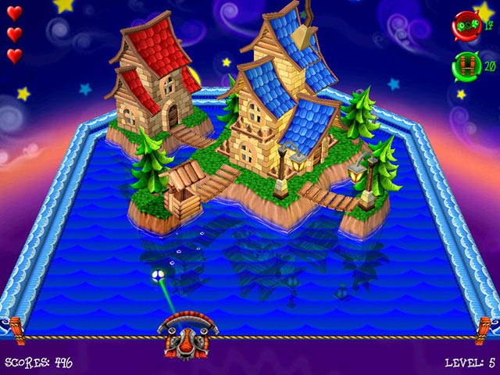  
This game was inspired by an old game called Smash Frenzy.  
Smash frenzy is a 3D brick breaker game consisting of power up that can that can help you beat the level and cause mayhem. So why not make this into a PVP and double the fun!

Just like your average pong game that consist of 2 players, this game will implement the chaos Smash Frenzy is made of. Speed  
duplicate, grow, and shrink, these are the elements that we implemented. There are 3 ways to win this Pong game, Score, Time-out and out of balls.

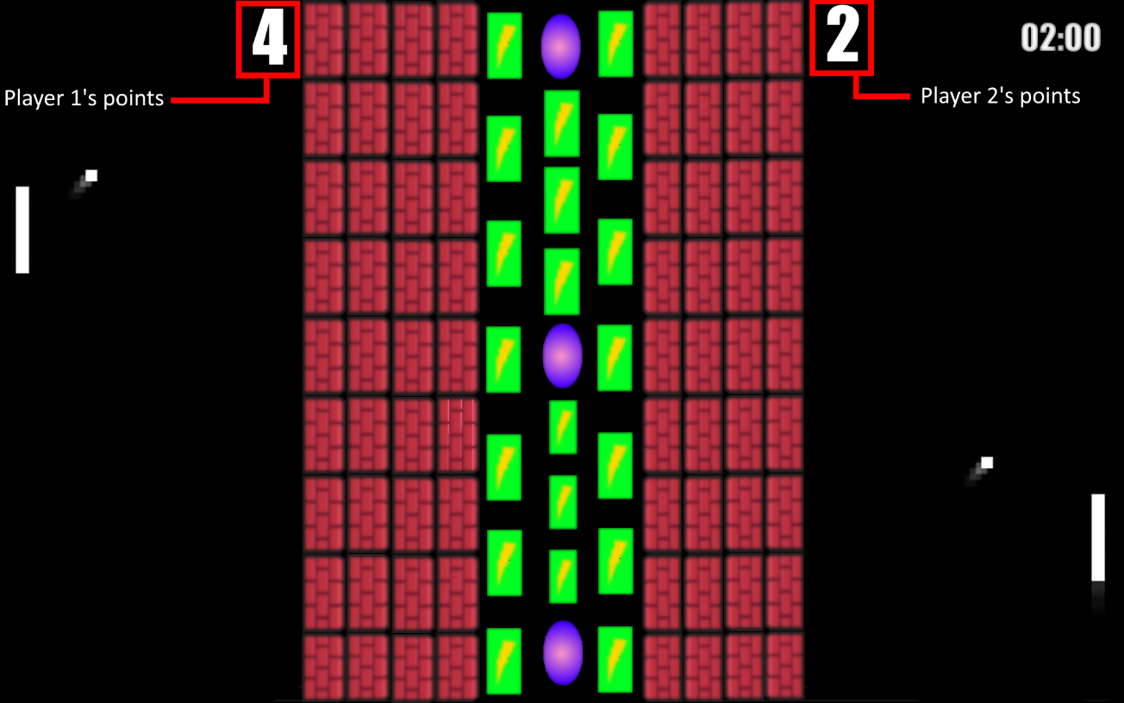There will be a score cap that will end the game once the cap has been reach.

If the score cap haven’t been reach, then a timer will end the game. The one with the higher score will win.

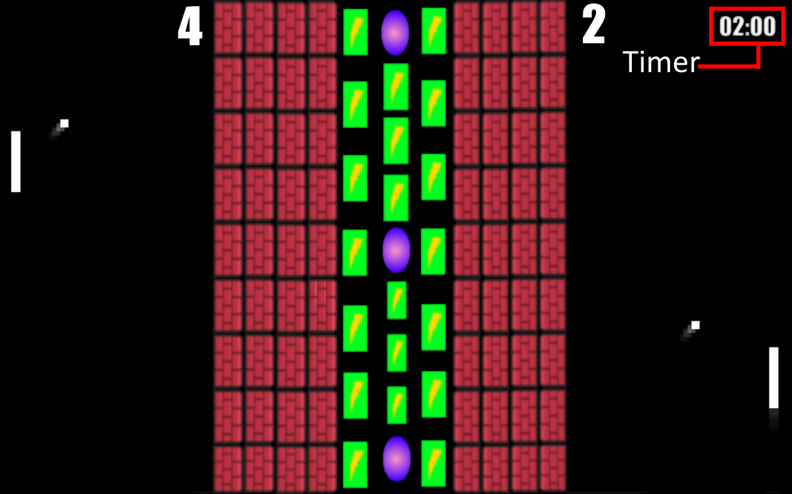

Lastly the balls, if there is no more balls the game will end automatically and the one with the higher point win.

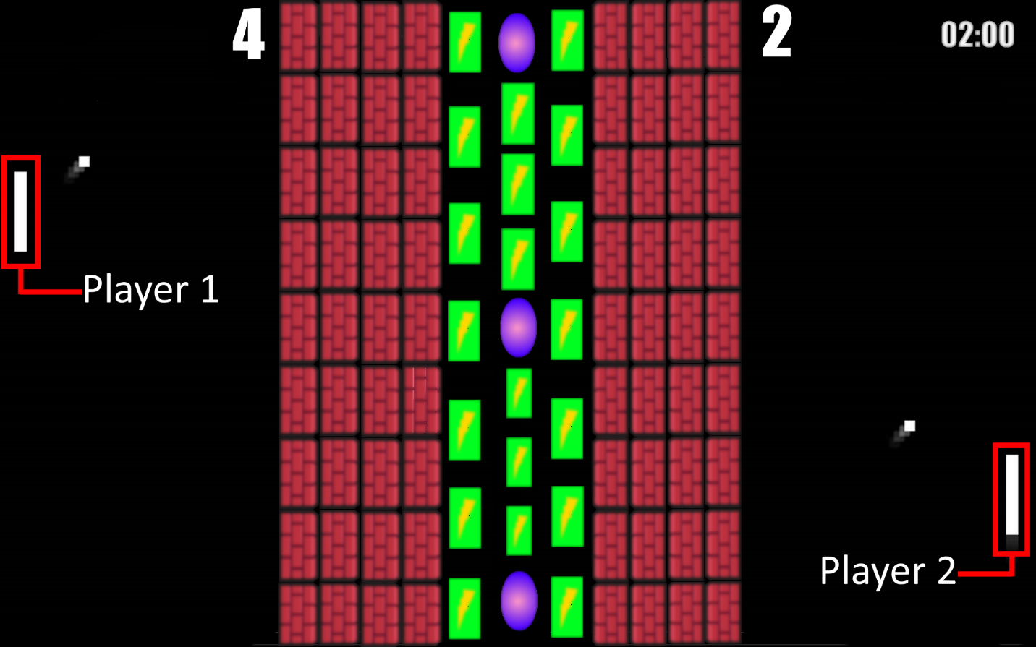  
  
  
Each side will consist of a player and start out with a ball. The player will only be able to move up and down. The objective of the game is to score the most points.

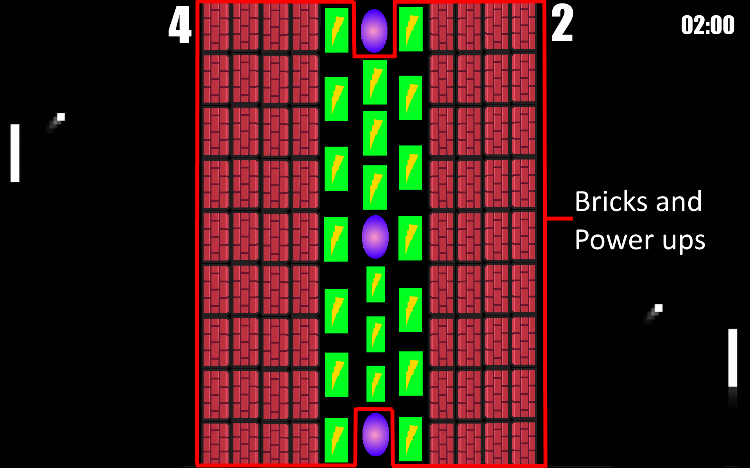Players can earn boost and advantages by breaking the block faster than your opponent. The middle consists of 11 columns of blocks, 4 on each side and 3 in the middle.

These blocks may contain features that will help you break the block faster. Points can also be gain by breaking blocks.

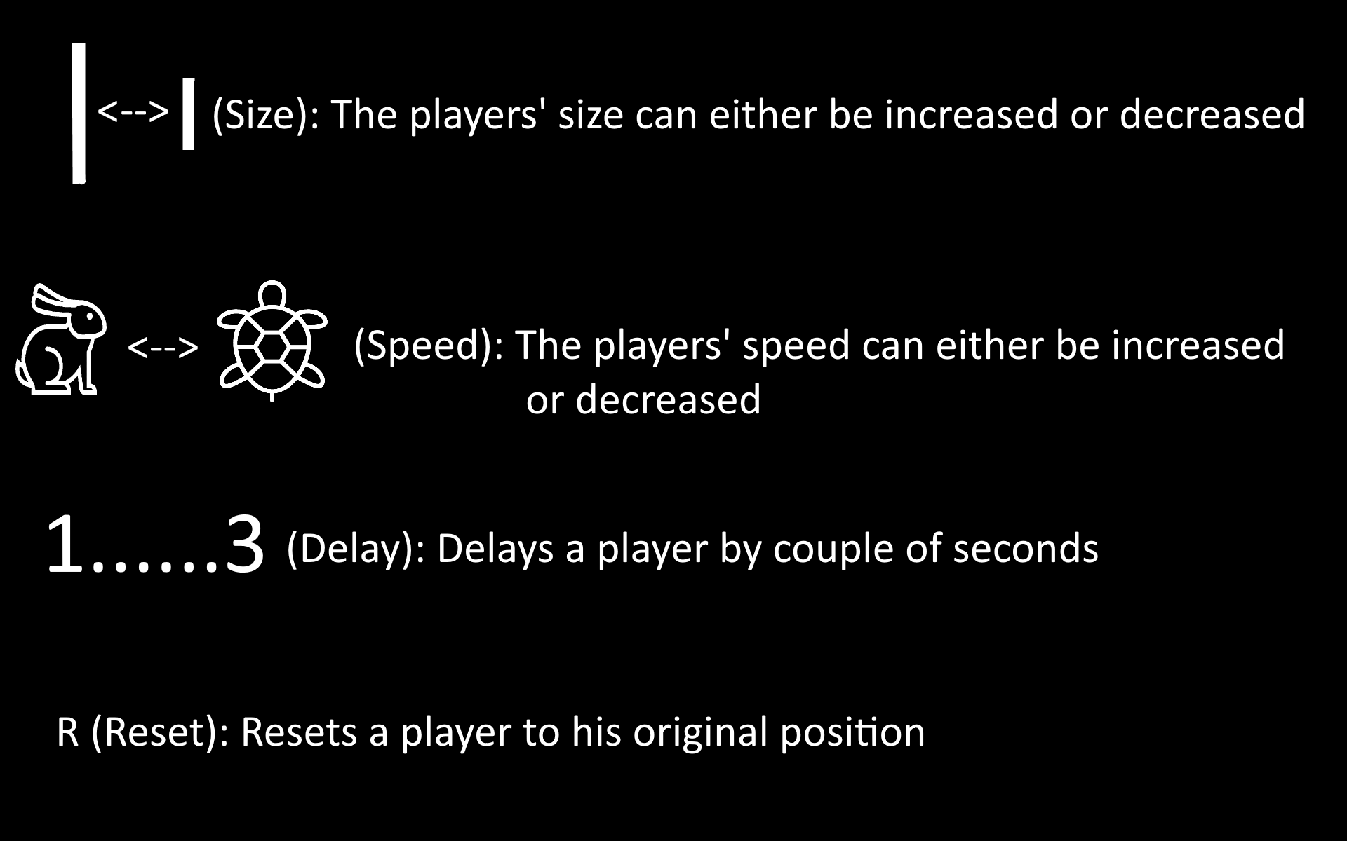

The 3 inner columns is where it gets interesting. It is where the power ups and power down are located.

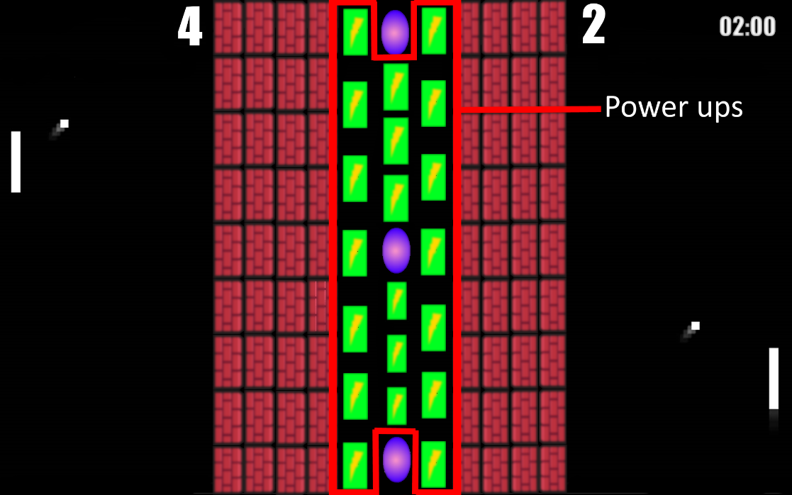

The side that the ball hit is the direction to where the power up/down will fall.

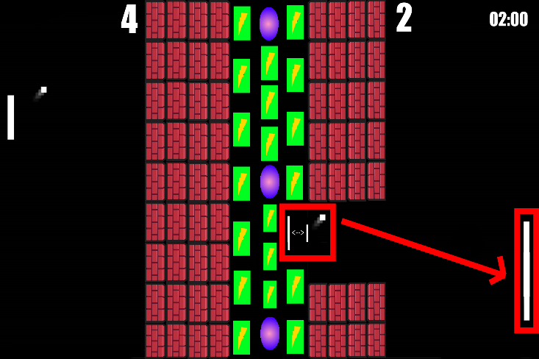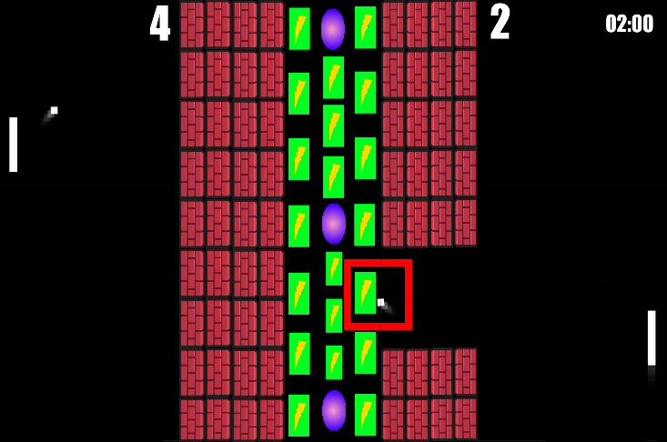

These implements can either make your player wider as well as make it faster while shrinking and slowing down the opponents. This is why breaking bricks faster is important.   
  
There are 3 portals, one on the top, center and bottom. These portal is what you can call mayhem portal.

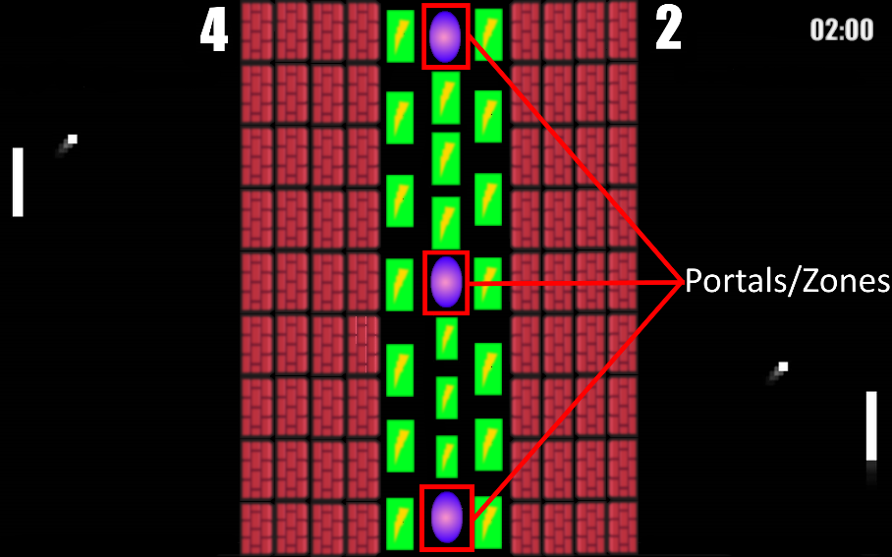

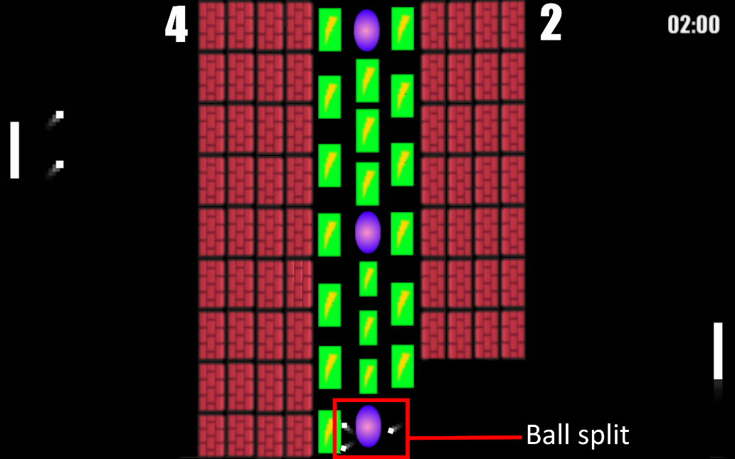These portal can either speed up, enlarge or split the ball. Once the ball hits the Y axis wall (edge of the screen), they will disappear and the point will be added depending on which side it touch.

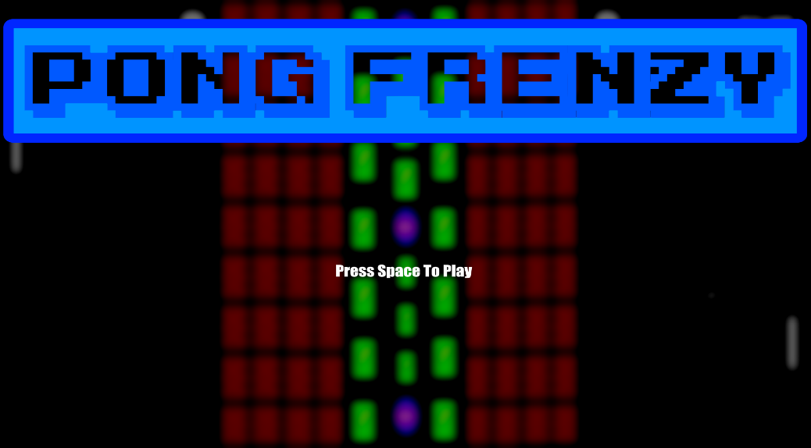Menu Screen:

Game Screen:

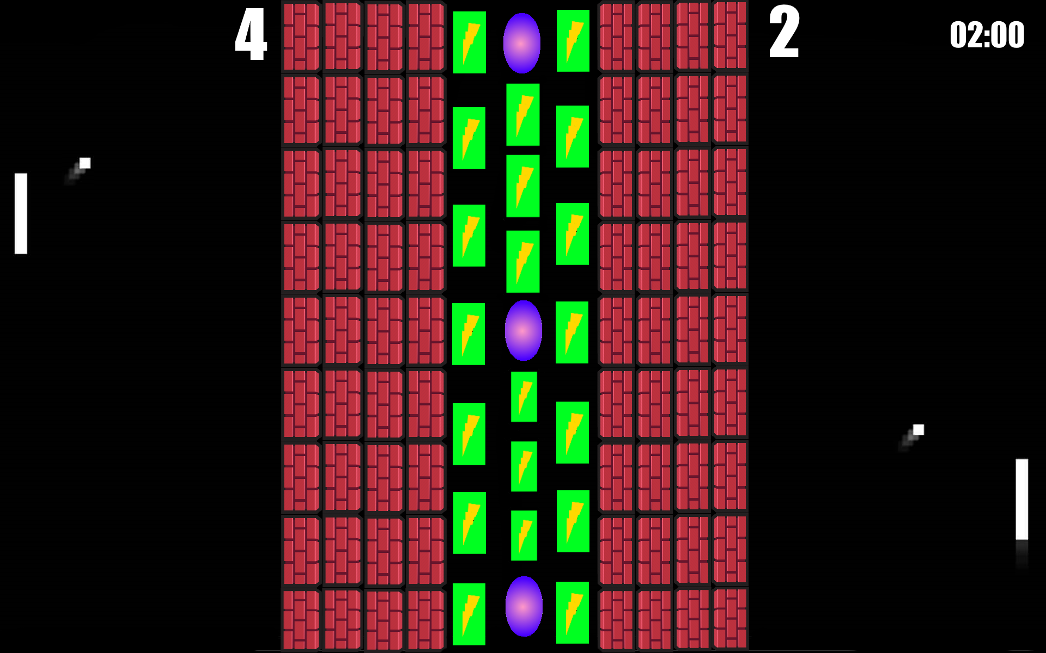

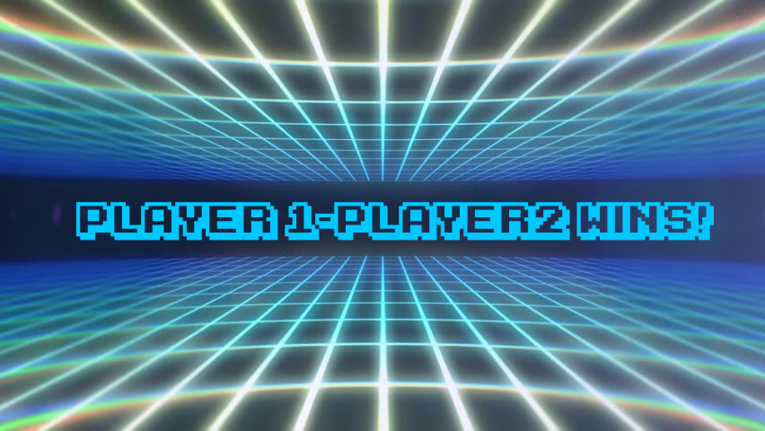End Screen:

Controls

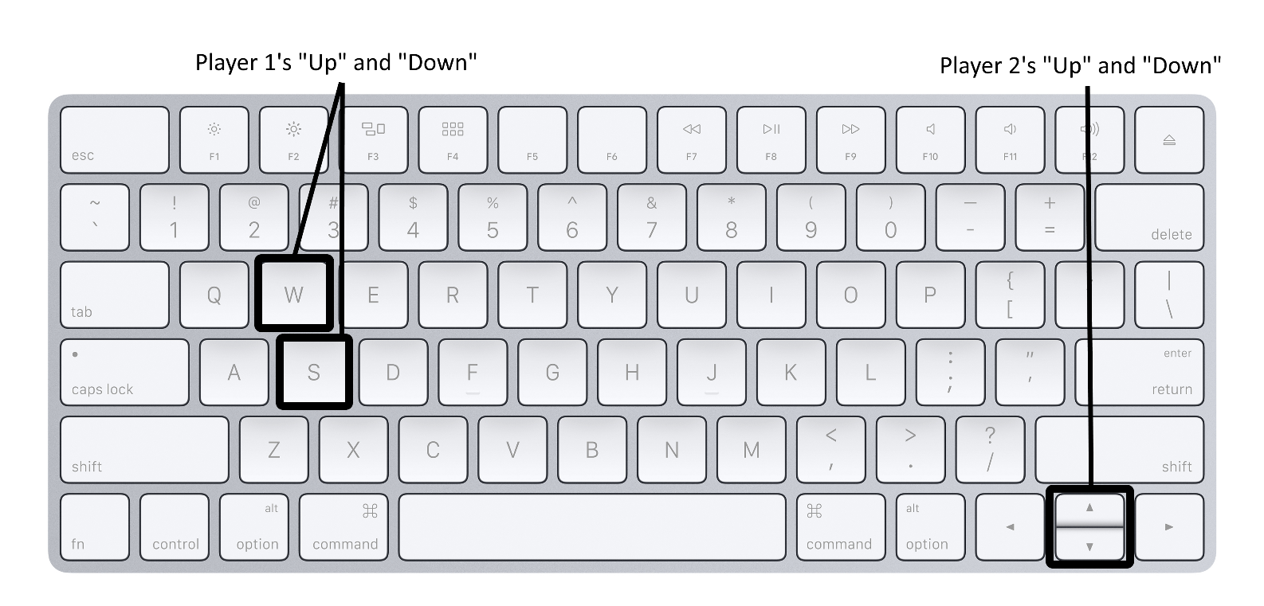

Team Tasks

For this project, each team member will be working on a specific part of the game.

Brandon: works on the ball(s) colliding with the bricks and the block drops

Chanki: works on making the ball(s) bounce with an angle of 90 degrees when intersecting with players, walls and block drops.

Geon:

Kevin: